

THE UNIVERSITY OF AZAD JAMMU AND KASHMIR, MUZAFFARABAD
Department of Software Engineering

Submitted to: | Engr. Sidra Rafique
Course Title: | Data Structure and Algorithm
Course Code: | CS-2101
Session: | 2024-2028
Lab No: | 06
Roll No: | 2024-SE-15
Submitted By: | Shahzad Ahmed Awan
Submission date: | December 20, 2025
Contents
Lab 06 – Sorting and Searching Algorithms Implementation 3
1. Objective 3
2. Background 3
3. Algorithms and Implementation 3
3.1 Linear Search 3
3.2 Binary Search 5
3.3 Bubble Sort 6
3.4 Merge Sort 7
4. Conclusion 8

Table of Figures
Figure 1: Code Implementation Linear Search 4
Figure 2: Output of the code of linear Search 4
Figure 3:Code implementation of Binary Search-2 5
Figure 4: Code Implementation of Binary Search -1 5
Figure 5: Output of Binary Search 6
Figure 6: Code implementation of Bubble sort 6
Figure 7: Output Bubble Sort 7
Figure 8: Code implementation of merge Sort -1 7
Figure 9: Code implementation merge sort 8
Figure 10: Output merge sort 8

Lab 06 – Sorting and Searching Algorithms Implementation

1. Objective
To implement Linear Search, Binary Search, Bubble Sort, and Merge Sort in C++ for searching and sorting arrays, demonstrating algorithm logic, array manipulation, and user interactivity.

2. Background
- Linear Search: Checks each element sequentially until the key is found.
- Binary Search: Efficient search on a sorted array using divide-and-conquer.
- Bubble Sort: Simple sorting by repeatedly swapping adjacent elements.
- Merge Sort: Efficient recursive divide-and-conquer sorting algorithm.
Advantages: Efficient searching and sorting; demonstrates algorithmic logic.
Disadvantages: Linear search and bubble sort are less efficient for large datasets.

3. Algorithms and Implementation

3.1 Linear Search
Algorithm:
- Traverse the array from start to end.
- Compare each element with the key.
- Return index if found; otherwise, indicate not found.
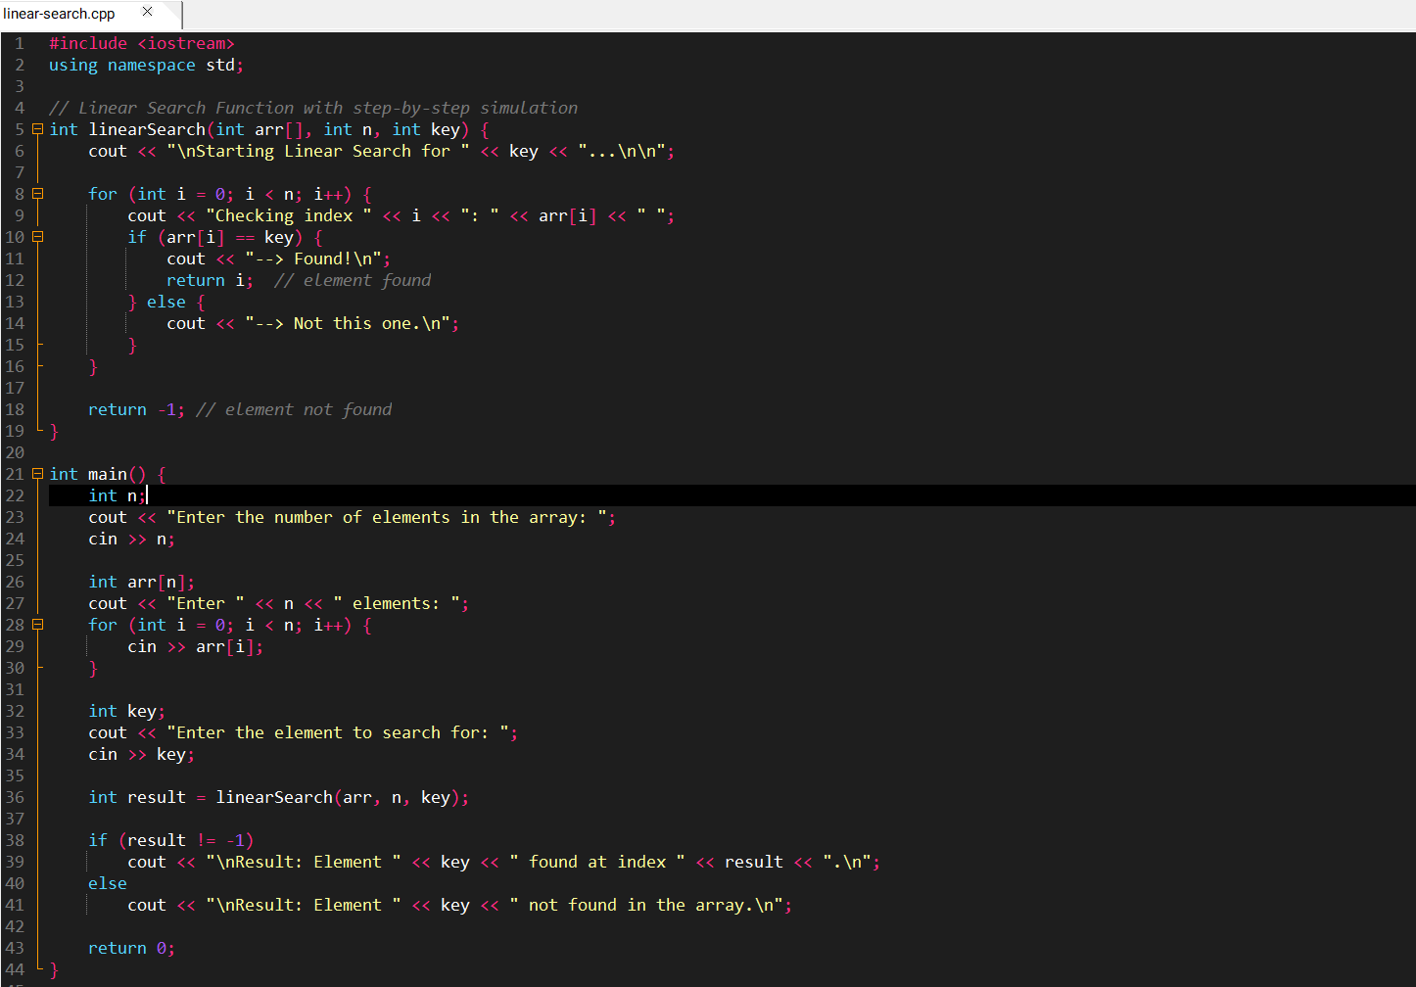
Sample Code Screenshot:
Figure 1: Code Implementation Linear Search
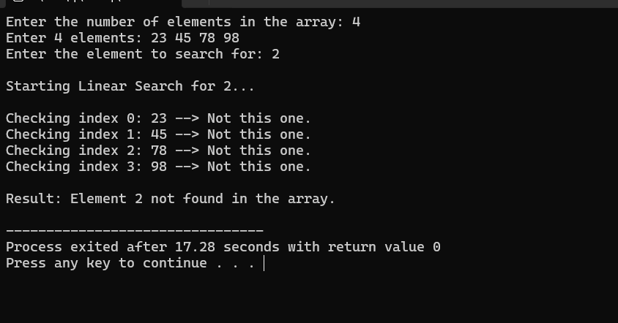
Sample Output Screenshot:
Figure 2: Output of the code of linear Search

3.2 Binary Search
Algorithm:
- Sort array automatically if not sorted.
- Compare key with middle element.
- Narrow search to left or right half until key is found.
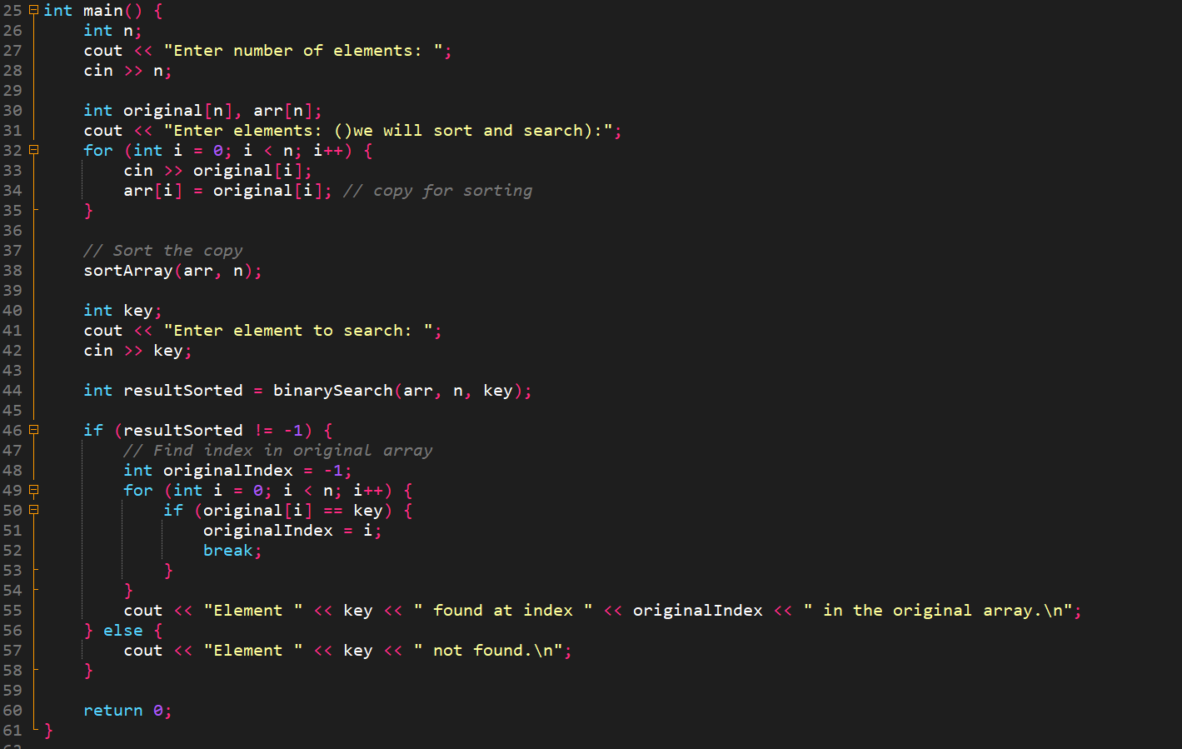
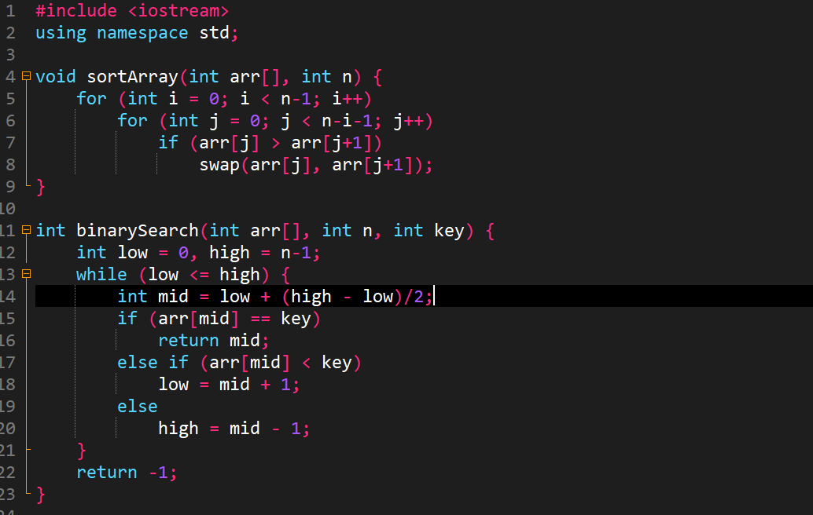
Sample Code Screenshot:
Figure 3:Code implementation of Binary Search-2
Figure 4: Code Implementation of Binary Search -1
Sample Output Screenshot:
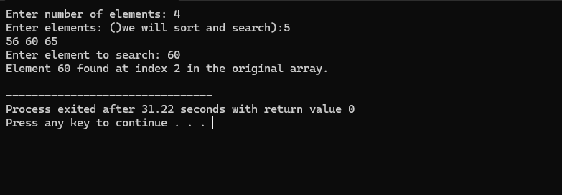
Figure 5: Output of Binary Search

3.3 Bubble Sort
Algorithm:
- Compare adjacent elements and swap if necessary.
- Repeat passes until the array is sorted.
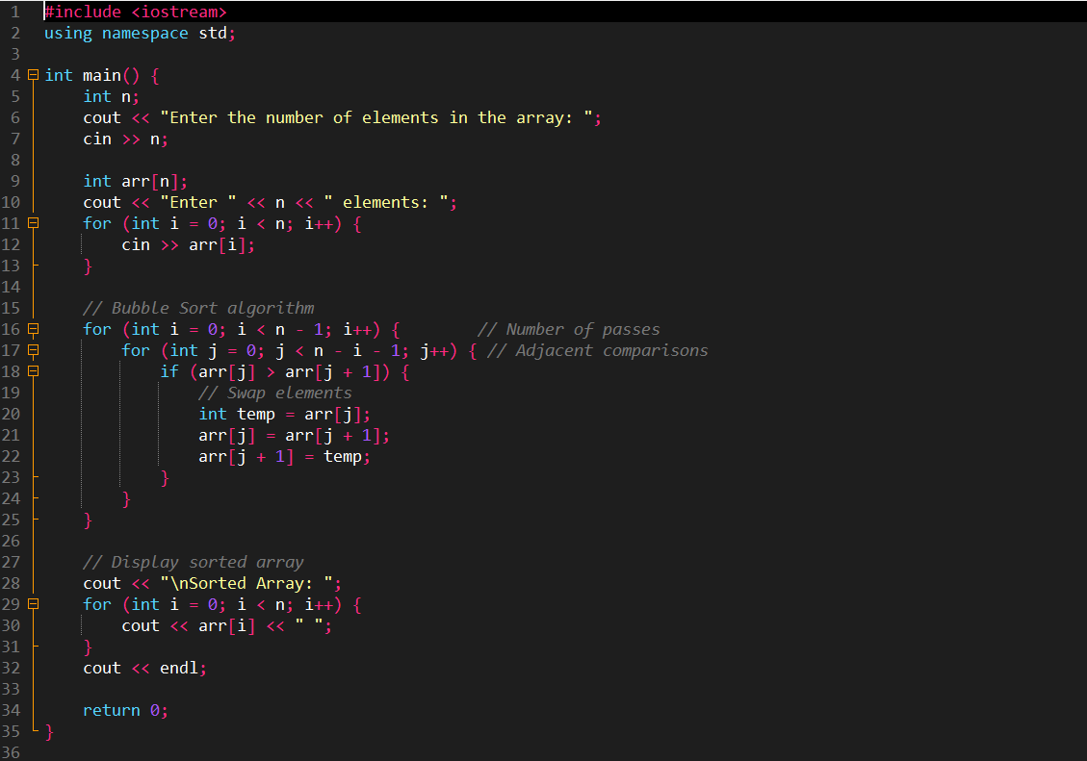
Sample Code Screenshot:
Figure 6: Code implementation of Bubble sort
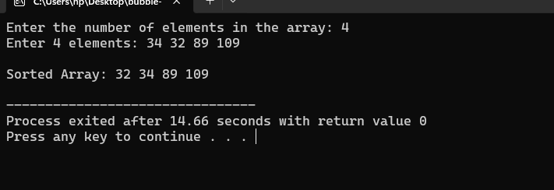
Sample Output Screenshot:
Figure 7: Output Bubble Sort

3.4 Merge Sort
Algorithm:
- Recursively divide the array into halves.
- Merge halves in sorted order.
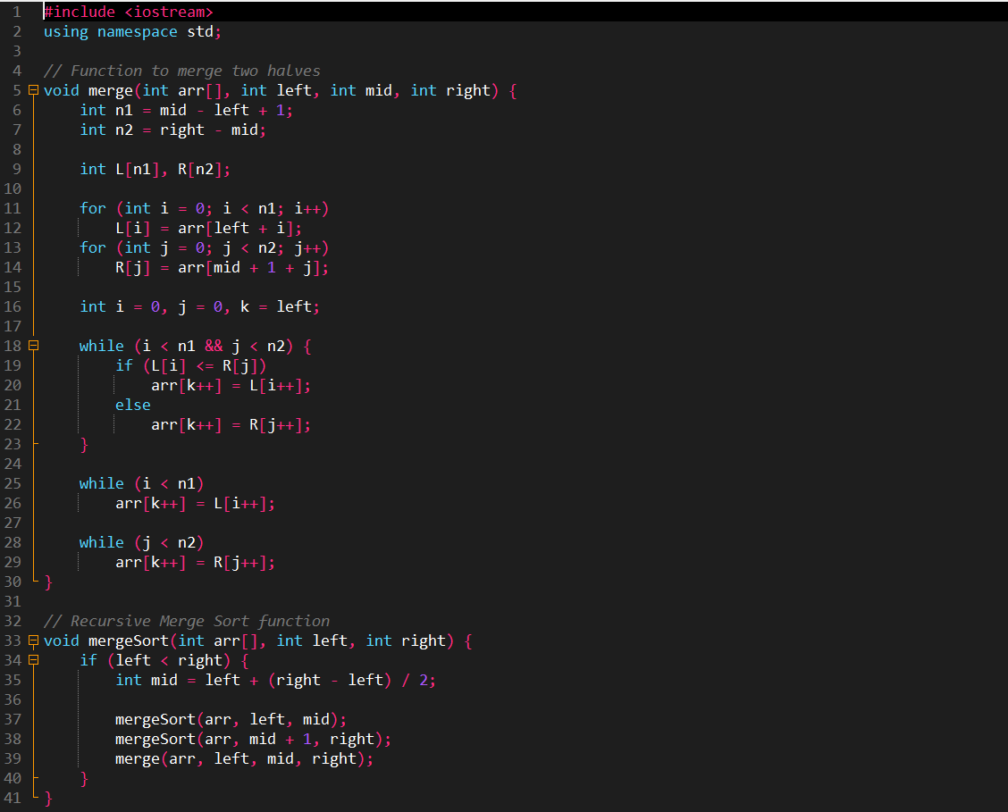
Sample Code Screenshot:
Figure 8: Code implementation of merge Sort -1
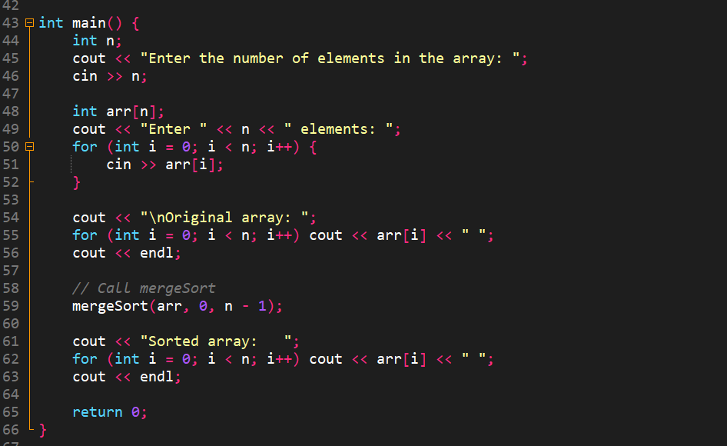
Figure 9: Code implementation merge sort
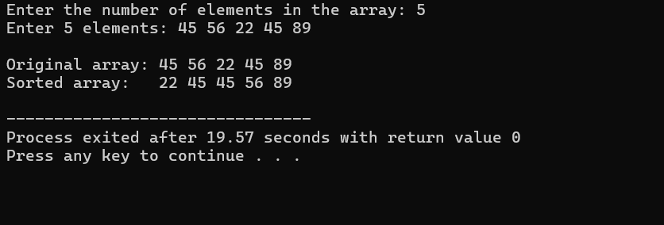
Sample Output Screenshot:
Figure 10: Output merge sort

4. Conclusion
- Successfully implemented searching and sorting algorithms in C++.
- Demonstrated array manipulation, automatic sorting, and efficient searching.
- Code is interactive and user-friendly, allowing dynamic input.

